**PIZZA SALES SQL QUERIES**

1. **KPI’S**

**1.Total Revenue**

select sum(price) as Total_revenue from pizzas;

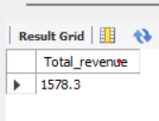

**2.Average Order Value**

select (sum(quantity * pizzas.price)/ count(distinct order_ID)) as Avg_order_price from order_details join pizzas on order_details.pizza_ID = pizzas.pizza_id;

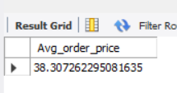

**3.Total Pizzas Sold**

select sum(quantity) as Total_pizza_sold from order_details

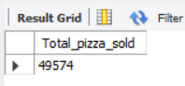

**4.Average Pizzas Per Order**

select sum(quantity) / count(distinct order_ID) as Avg_pizzas_per_order from order_details

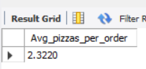

**5.Total Order**

select count(distinct order_ID) as Total_orders from orders

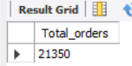

**1.Daily Trends For Total order**

select dayname(order_date), count(distinct order_ID) as total_order from orders group by dayname(order_date);

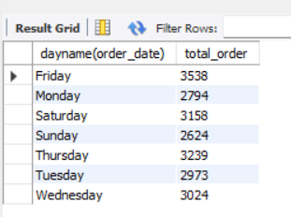

**2.Monthly Trends for Total Order**

select monthname(order_date), count(distinct order_ID) as total_order from orders group by monthname(order_date);

